Aisling Iris press release 2017

Aisling Iris

Night time moves
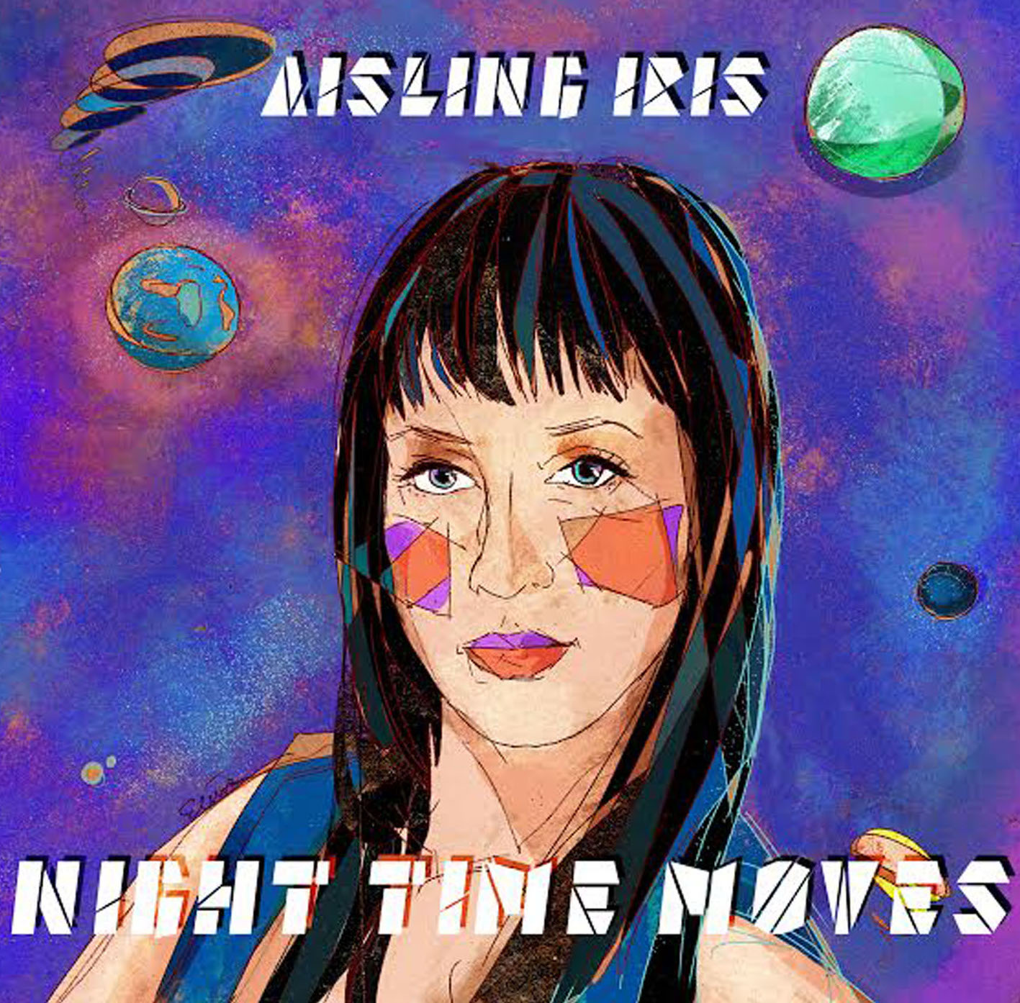

Night Time Moves is the new album from Irish singer songwriter Aisling Iris.

'Irish singer Aisling Iris followed with a superb new collaboration with saxophonist Tony Kofi…. Iris’s voice was a revelation: her control over the whole range is immaculate, her expression powerful, and her feel for the essential elements of Monk’s music quite extraordinary' – thejazzbreakfast
Currently making waves in the London music scene, ‘Night Time Moves’ is the self-penned debut studio album by Aisling Iris. Its title track, with its Latin-infused, jazzy soul groove has featured on Jamie Cullum’s BBC Introducing show, with Cullum likening the song to soul star Omar.
‘Passing Clouds’ an uplifting jazz soul track from the album is a collaboration with UK soul royalty Andrew Mclean (multi instrumentalist, younger brother of soul star Don E and drummer with the Grace Jones band) has proven a firm favourite with stations such as Jazz FM, Mi-Soul and Delite radio, earning her praise from Acid Jazz heavyweights; Simon Bartholomew of The Brand New heavies mentioned Aisling as “one to watch” during an interview for Craig Charles Funk & Soul show on BBC Radio 6, while drummer Derrick Mckenzie of Jamiroquai has called her “very inspirational” to work with as a songwriter and vocalist.
‘Night Time Moves’ features diverse talents ranging from Latin Grammy nominee, Cuban trumpeter Yelfris Valdes, to American saxophonist and bandleader for the ‘Conan O Brien show’ house band Jerry Vivino. The album is Produced by Drew Horley. who has worked with UK Jazz favourite Natalie Williams from the beginning of her career and Mercury nominee UK rapper Ty. Collaborator Andrew Mclean has co-written four songs on the album, alongside a multitude of instrumental credits.
Hailing from the small rural town of Cork in Southern Ireland, Aisling moved to London in her late teens. She credits her mother for passing down her musical abilities and honed her skills attending late night jam sessions in London, collaborating with musicians and producers she met along the way.
“Everything I’ve learned about music and songwriting has been through my own experience and personal study of the greats like Marvin Gaye, Herbie Hancock and Betty Carter.
My album is a result of a self-discovery and realization that I have to be true to my art whatever the consequence which means that the album is very much a mixed bag. Don't expect to hear one song after the other sounding similar, my tastes are very varied and so it stands to reason that the music I make, although very much steeped in soul and jazz, doesn't stick to just one format. There is disco, there is funk, a little Latin and hip hop "

Notes to Editors
Aisling is the executive producer of ‘Night Time Moves’, largely funding the production through a successful Pledge campaign.
Her eclectic talents have seen her touring as support to Roots Manuva, working with such artists as Phil Asher and supporting UK legends Omar, the late Lynden David Hall and Eska Mtungwazi and playing to over 4000 music fans at the Summer Soulstice festival sharing the bill with Shaun Escoffery, Steve Arrington and Push
Aisling fronts “Neon Villages,” The group has supported Marcus Miller on his Afrodeezia tour, and “Monk the final frontier Quintet” an ensemble which pays homage to the music of Thelonious Monk. Featuring UK jazz saxophonist Tony Kofi and Jonathan Gee along with former Gil Scott Heron drummer Rod Young
Recent appearances include a trio of shows at the 2017 Cheltenham Jazz Festival, including exclusive backstage Henry Weston’s Sessions – captured on video here: https://www.youtube.com/watch?v=1zJgZ43uB3A
Previous releases include E.P. “You Took The Sun Away”
Management = Heather Taylor heather@redfiremusic.co.uk http://www.redfiremusic.co.uk/
For more info promo requests or to set up an interview, please contact info@aislingofficial.com

For live dates and all social media links visit. www.aislingofficial.com

